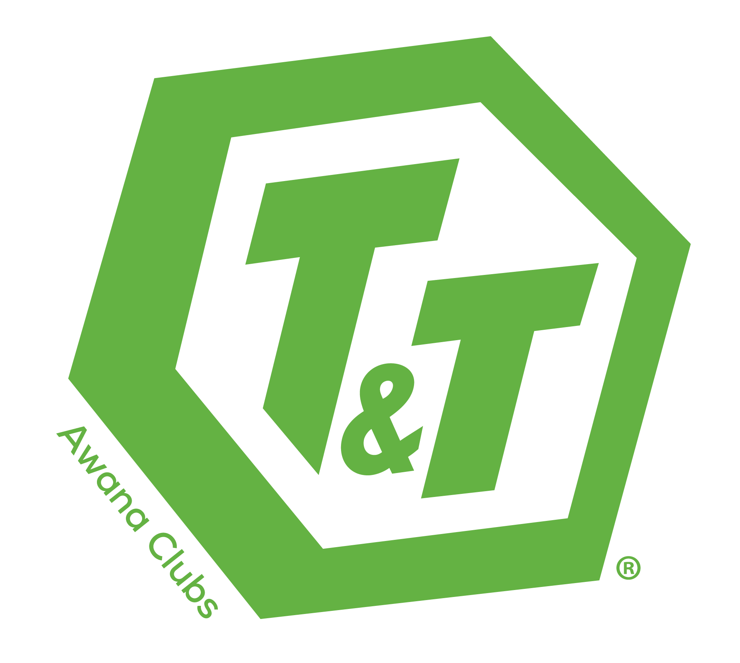journey-logo06MC900014087[1]MC900014089[1]MC900014088[1]

**Awana is a three-part program with a focus on the gospel and life-long discipleship.**

**AWANA OFFERS FUN AND EXCITING GAMES,** unique to Awana, that allow kids to participate no matter what their skill level.

**AWANA OFFERS SMALL GROUP TIME** with a caring adult leader. No one gets lost in the crowd. Children receive individualized attention as they work through an introductory booklet and then an age-specific handbook.

**AWANA OFFERS AN INTERACTIVE LARGE GROUP SEGMENT** where kids meet together to sing, hear a Bible lesson and receive awards. Awana leaders go the extra mile to help your kids understand the Bible and how it applies to their lives in an exciting and challenging way.

**Learn more at www.awana.org**

**What programs are offered?**

**Puggles®** recognizes the learning ability of **two and three year olds** by introducing biblical precepts at church and equipping parents to teach them at home.

**Cubbies®** celebrates the spiritual potential of **preschoolers** (the two years before kindergarten) by helping them develop respect for God, His Son and His Word.

**Sparks®** ignites the curiosity of **Kindergarten through 2nd graders** to learn about the people and events of the Bible, building a foundation of wisdom for knowing Jesus Christ.

**Truth & Training®** engages **3rd through 6th graders** by answering their questions about God and the Bible; guiding them through this pivotal life stage to grow in the grace of the Lord Jesus Christ.

**Trek®** challenges **middle school students** to consider their destiny in Christ and pursue it through life application of God’s word.

**Journey**® establishes **high school students** as lifelong disciples through a deep study of God's Word, mobilizing them to live with godly perspective and evident faith.

**What is Awana?**